Here is a list of some of the many awesome resources Grants Public Library has to offer our community:
You can visit our website at https://www.cityofgrants.net/library
for these and other links and resources for the Grants Public Library. As always feel free to ask any one of our wonderful staff for assistance and we’ll do our absolute best to help you.

Through interlibrary loan we request a title we may not have in our collection from another library and in turn loan it you, our patrons. It’s an easy, FREE process. Just ask any of our staff for info.
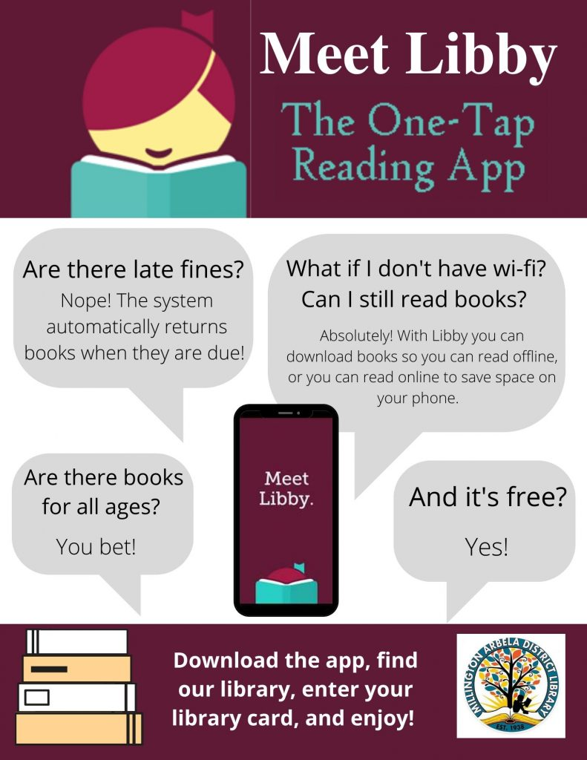
With OverDrive/Libby you can access hundreds of Audiobooks and eBooks online. Another FREE resource you can take advantage of with your library card. Quick and easy. Search www.overdrive.com/apps/libby
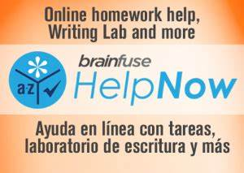
Brainfuse has many wonderful help tools for everyone from elementary school to high school to college to adults entering into the work force. Live online support for math & reading tutoring as well as GED test prep. ACT and SAT study guides and pretests.
El Portal is a wonderful resource that offers Resume templates, job search links, periodicals, Chilton and so much more. Free for library patrons at elportalnm.org or New Mexico State Library HelpNow - Online Tutoring (brainfuse.com).

GREENSCREEN
Did you know we have a green screen available for public use here at the library? Students can come in and film their presentation against the green screen then add their own background in editing. Do you have a PSA or advertisement you’d like to shoot, we have the green screen. Possibilities are endless.

Room Rentals:
We have rooms available for rent for meetings, testing, conferences, trainings or any other type of gathering you may have. Rental cost is $10 for 1-4 hours and $25 for 4 hours or more. Refreshment are welcome with a small deposit.

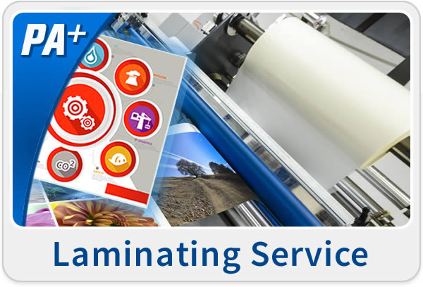
Another awesome service we offer is lamination. We can laminate anything from wallet size to poster size.
We also offer other great services such as public access computers for essential use, fax, prints, copies, scanning, emailing and notary.
Ask one of our helpful staff for further information and cost for any one of these services.
You can come relax and work on a puzzle in our puzzle area or take a puzzle home to work on and then return it for another. Or bring some friends and check out a board or card game and have some fun playing games.

Grants Public Library
1101 N 1st St.
Grants, NM 87020
(505)287-4793
Mon-Fri 8:30-6:00
Sat. 9:00-2:30

